**ABOUT US**

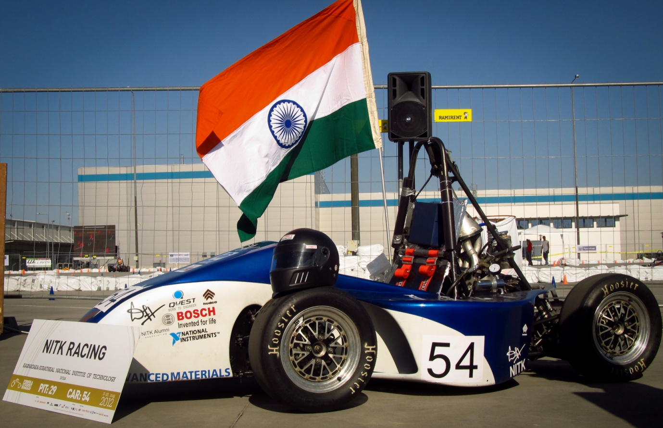

*The DH NR-XII at Formula Student Hungary*

We are NITK Racing, a group of dedicated students from the National Institute of Technology Karnataka, Surathkal working towards one goal: to participate in the Formula Student Series of competitions and achieve a top 10 spot.

The team had its humble origins in 2007, when it participated at the first ever SAE-India Baja competition. The competition required the teams to build an off-road buggy or ATV (All-Terrain-Vehicle). Since then, NITK Racing has participated in every annual edition of the competition. As the years rolled, the team saw great successes and looked to go international- to the Formula SAE events. It was decided to have two teams work simultaneously on two distinct cars each season. As a result, the Formula Student team of NITK Racing was formed. Now, NITK Racing participates at the Baja competition as [*Junkyard Maniacs*](http://www.nitkbaja.com/), who have consistently performed well to achieve top spots.

Our first Formula Student experience was at FSAE Michigan in May 2011, with our car, the C&C Alpha NR-XI. However, a logistics failure restricted our participation to the Static Events . The next year, we participated at FS Hungary 2012 with the DH NR-XII and were able to secure a top-ten spot in two events.

**What is SAE?**

Society of Automotive Engineers (SAE) is a global body of scientists, engineers, and practitioners that advances self-propelled vehicle and system knowledge in a neutral forum for the benefit of society. With more than 132,000 engineers and related technical experts in the Aerospace, Automotive and Commercial Vehicle industries, SAE's core competencies are life-long learning, networking, and voluntary consensus standards development. Members and volunteers come together through SAE to freely exchange ideas, share information and develop technical information on all forms of mobility vehicles for the aerospace, automotive and commercial vehicle industries.

SAE INDIA is India's leading resource for mobility technology. As an individual member driven society of mobility practitioners, the ownership of SAE INDIA rests with its members who are individuals from the community; this includes engineer executives from industry, government officials, academicians and students.

**What is the competition? or What is Formula Student?**

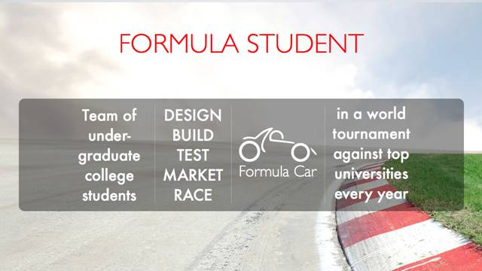

Formula Student / Formula SAE is a student engineering design competition organized by SAE (Society of Automotive Engineers) International. This challenge involves building a Formula-style race car for the avid amateur autocross racer. Teams entering the competitions are run and operated solely by university students, thus helping them develop their skills in design, management, communication and research in a real-world environment. It not only tests the students’ ability to learn but helps them build, design and present a car, thus nurturing the talent of the student and exposing them to a complete engineering design challenge.

Backed by reputed industries and high-profile engineers, this competition proves to be the perfect opportunity for university students to gauge the real-world, thus bridging the gap between the classroom to and the workplace. An established education motor-sport competition, Formula Student attracts some of the brightest minds from the universities and industries. It also remains as one of the most comprehensive competitions for university students.

Over the years, the Formula Student program has expanded and now functions as a series of competitions. In a season, there are 11 competitions that are held in as many venues around the globe (USA: Michigan, Nebraska; Hungary, Germany, UK, Italy, Austria, Spain, Brazil, Japan, Australia). Each of this competition serves as a world tournament by itself. Teams are free to participate in as many races they can in the season.

More on SAE can be found at:  [*http://www.sae.org/*](http://www.sae.org/)

More on the competition can be found at :  [*http://students.sae.org/competitions/formulaseries/*](http://students.sae.org/competitions/formulaseries/)

More on NITK Surathkal can be found at:  [*http://nitk.ac.in/*](http://nitk.ac.in/)